Nett Win Contribution
Cricket is a bat-and-ball sport contested by two teams of eleven players. In the T20 cricket format, each side bats once. The team batting first scores as many runs as they can while the team batting second then attempts to surpass that total. At the end of the match, the side with more runs wins. A team's turn to bat is called an innings. It ends when either 120 legal deliveries (balls) has been bowled, ten of the eleven batters have been dismissed, or the team batting in the second innings has surpassed the first innings total (whichever comes first). A legal delivery is a delivery bowled that is NOT a wide or no-ball (a penalty attributable to the bowler). While a dismissal is a method (bowled, caught on the full…there are 10 main ways) which results in the batter being eliminated from the game. This creates cricket’s central tension: batters must score quickly enough to build a competitive total, but not so recklessly that they lose their wickets and end the innings early. Two batters are on the field (a striker and non-striker) at any time, facing deliveries bowled one at a time. While one team bats, all eleven opponents are on the field: one bowls, one wicket-keeps (a fielding position stationed immediately behind the batter), and the remaining nine players field the ball to prevent runs and effect dismissals. Players usually specialise as batters or bowlers.
Win probability models (WPM) are a macro indicator of team-level performance and have a number of practical applications in cricket (e.g., for sports broadcasting, sports betting, in-house within cricket organisations). However, as the units of a cricket game are discrete (ball-by-ball) and win probability values change after every delivery, we can attribute the micro-level ‘value’ of a batter and bowler interaction based on the win probability difference prior and following a delivery. This creates a zero sum system, such as a chess match where one player loses and the other wins. By aggregating the change in probability for a player of interest, stakeholders (e.g., Cricket Australia) can assess ‘which players have had the greatest impact on the match?’ Therefore, the aims of this project include:
- Construction of a comprehensive feature set that captures the current game state and quality of batters and bowlers still available in the match.
- Development of a well-calibrated model that can estimate the likelihood of the batting team winning the match.
- Quantification of the novel metric, Nett Win Contribution, which will be used for player evaluation.

Feature Engineering
The features used for modelling aim to capture elements that provide signal to the question – based on the current situation of the match, is the batting team likely going to win? These features may include information related to the game state (what is the current game situation), quality of bowling and batting remaining (what is the quality of the current batter and bowler, and players left to bowl or bat?), environmental conditions. The primary challenge of the feature engineering stage is to quantify the quality of batting and bowling resources dynamically as an innings progresses. This is particularly important before the first delivery of a match, when no match-state information exists and the ML algorithm must rely solely on the inherent quality of the batting and bowling resources to generate predictive signal. Some ideas around this include:
- Quantifying conventionally used statistical measures (see the feature engineering script for a description of these) for each batter and bowler, and updating these longitudinally with performances over time.
- Using these conventional statistics to ‘cluster’ players into distinct categories.
- These categories may then be able to define the quality or characteristics of the batting and bowling resources remaining.
Modelling should additionally acknowledge the difference in batting objectives between match innings – where first innings batters have the objective of maximising the runs scored, while second innings batters must chase a score set in the first innings. Note that the features, required run rate and run rate differential, should only be included for deliveries in the second innings. Additionally, modelling should be done separately according to gender as performance outputs and teams are structurally different. See the data dictionary and feature engineering script for the construction

Modelling
Ball-by-Ball In-Play Win Probability Model
Can start with a simple logistic regression and then a more complex ML architectures. The most accurate model based on log loss will be selected. Naïve classifier is simply the empirical distribution of the feature win the match in the training set.
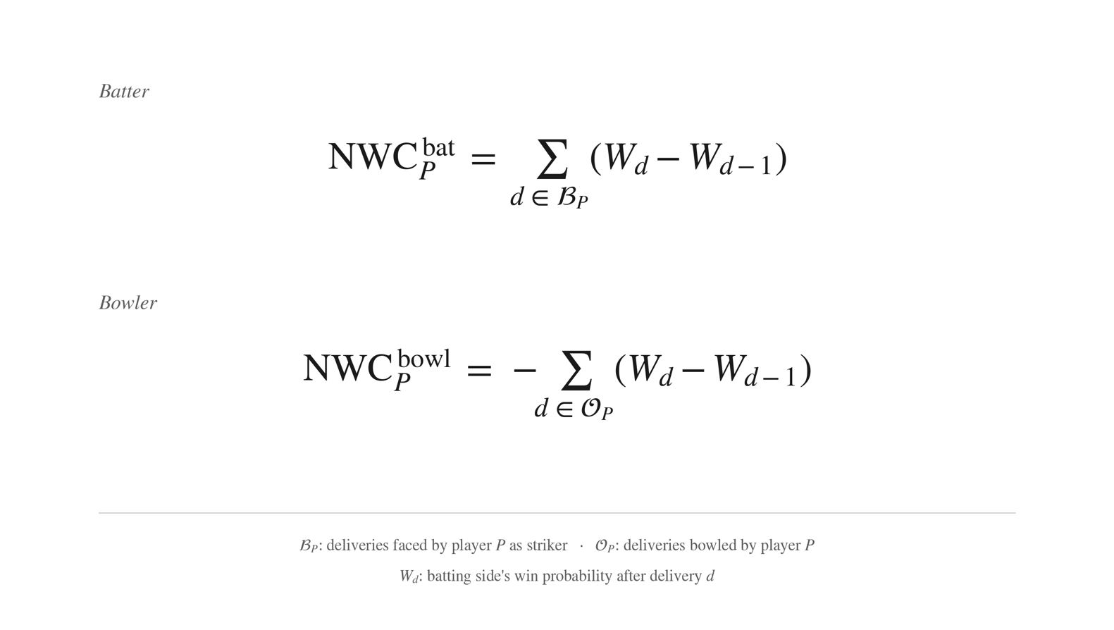
Nett Win Contribution Metric
Derives the Nett Win Contribution metric by calculating the change in win probability across each delivery and attributing it to the batter and bowler responsible. For example, say I am batting in the first ball of a match and the WPM values my chance of winning at 50%. She then hits the first ball for a 6. Following this event, the WPM has moved from 50% to 52% - meaning her action of hitting a 6 has moved the win probability by 2%. These per-delivery values are aggregated across a match, season, or career to produce a single, outcome-anchored measure of player contribution.

